**Data Methodology**

**Step 1 – Story Boarding**

* Gone through the data to understand and get familiar with it.
* Thought about the insights which we can get from the data

**Step 2 – Data Cleaning**

* Again, gone through the data once to check if any missing values and duplicates present in the data
* Checked if any null values are there or not.

**Step 3 – Data Analysis**

* Found out the top 10 popular hosts who listed the property among the customer by the no. of reviews.
* Applied the filter to the host name to find out the top 10 hosts with most no. of reviews.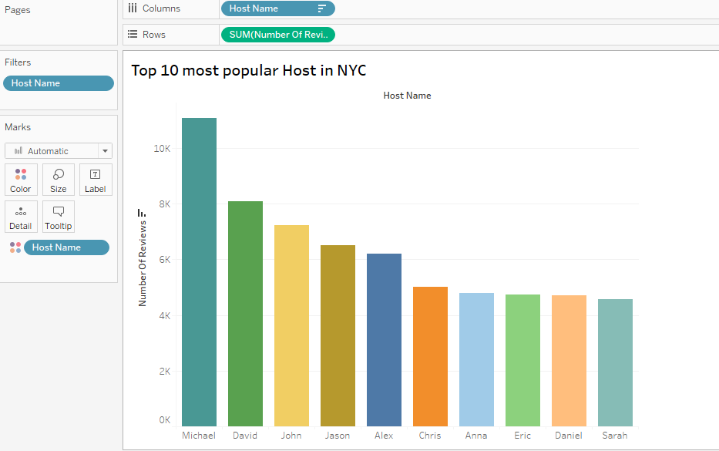
* We can see from above fig. Michael is most popular host among all.
* Also, prices of room types varies “Entire rooms can cost more as compared to private and shared room” below is the image provided for your reference.

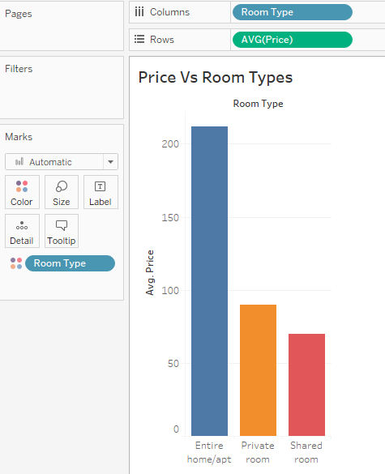

Also, I created a grouped field for no. of nights for further analysis purpose to find the price distribution for following nights of stay.

Below I have provided the snapshot of calculation for No. of nights for reference.

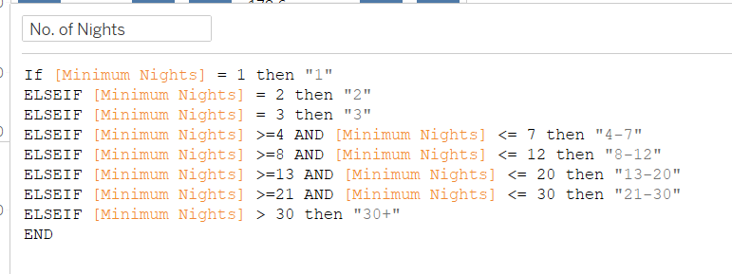

* 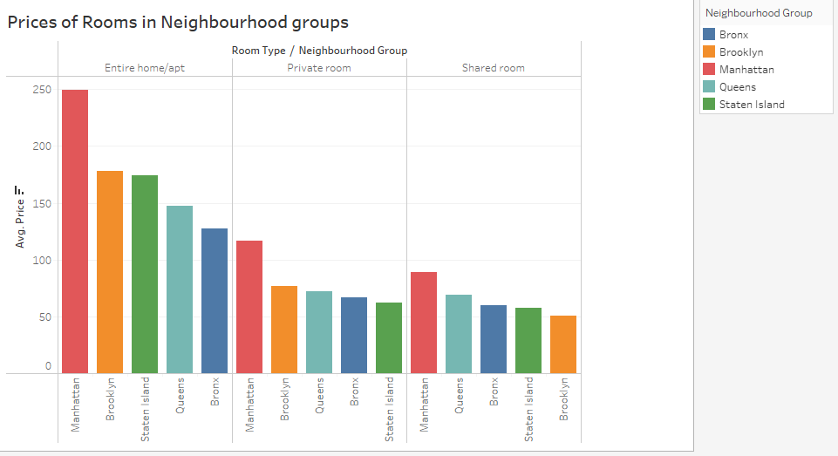Checked neighbourhood grouped wise distribution of price and room type.

From the above figure we get the keys insights as mentioned below

* Entire apartments are popular and so are private rooms
* Except in Manhattan, shared rooms are very unpopular
* Entire room’s reviews per listing for Manhattan is 35% lower than the overall average and number of listings is the highest
* Manhattan is costliest overall and the cheapest are:
* Entire apt: Bronx
* Private room: Staten Islands
* Shared room: Brooklyn

**Step – 4**

* Prepared the presentation following the rules and pyramid principle.